# PRACTICAL NO: 02

**AIM: MongoDB inert document, query document, update document, delete document.**

Basic Commands

1. Version check

Syntax: mongod –version

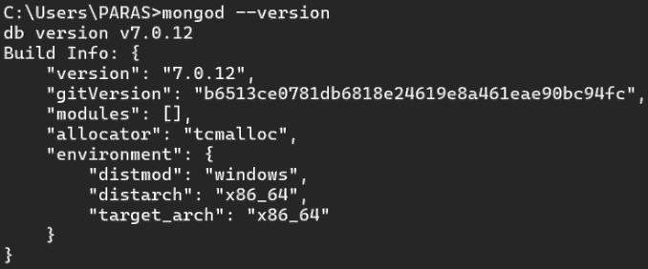

1. Listing MongoDB commands

Syntax:help()

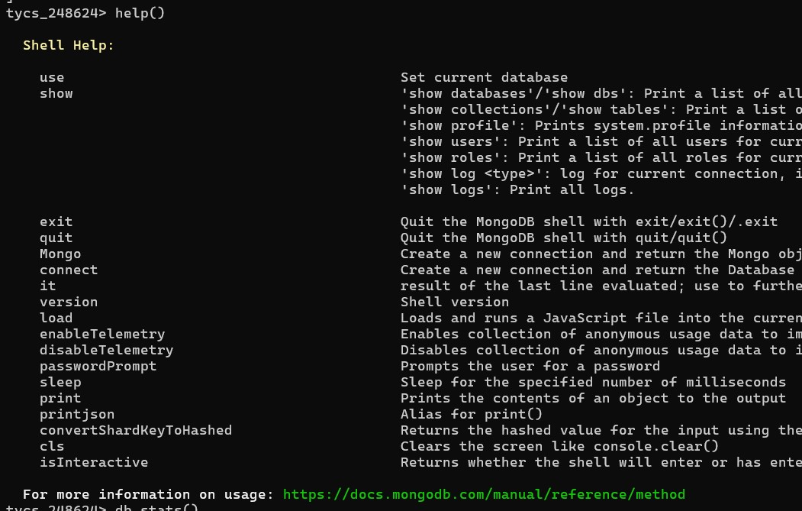

1. 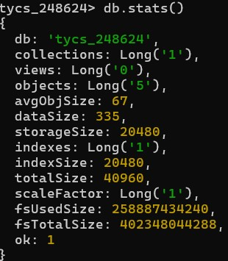DB statistics Syntax: db.stats()

1. Update Document in a Collection

Syntax: collectionName.update({KeyToUpdate},{Set Command}), db.collection.update({*criteria*},{$set: {*new value*}})

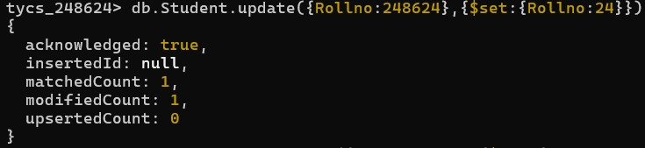

5.

To update

multiple documents on some condition MongoDB has

updateMany()

method.

Syntax: collectionName.updateMany({filter},{Set Command})

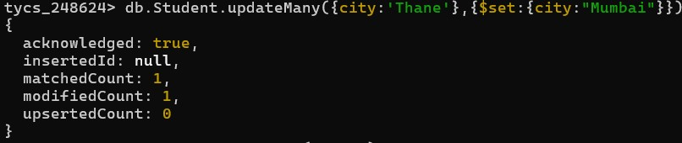

6. Delete Document of a Collection

• deleteOne({condition}): removes the single document meeting the deletion criteria. Syntax: collectionName.deleteOne({DeletionCondition})



1. remove()

Syntax: collectionName.remove({DeletionCondition},1)



1. Retrieve Distinct

* To get distinct records from one field.

Syntax: collectionName.distinct(field)



* To get distinct records from one field while specifying the query.
* Syntax: collectionName.distinct(field, query)



**9.** Rename collection

**Syntax**: collectionName.renameCollection(newCollectionName)



**Queries**

1. Write a MongoDB query to display all the documents in the collection employee.
2. Write a MongoDB query to display the fields employee_id, name, department, and salary for all the documents in the collection employee.

db.Employee.insertMany([{ename:"Paras",eid:01,dptname:"Cs",salary:25000}, {ename:"Sanket",eid:02,dptname:"IT",salary:13000},

{ename:"Sai ",eid:03,dptname:"HR",salary:15000},

{ename:"Sangram",eid:04,dptname:"CS",salary:25000},

{ename:"Omkar",eid:05,dptname:"IT",salary:10000},

{ename:"Ketan",eid:06,dptname:"HR",salary:15000},

{ename:"Saif",eid:07,dptname:"CS",salary:25000},

{ ename:"Sujal",eid:08,dptname:"CS",salary:15000},

{ename:"Hemant",eid:09,dptname:"IT",salary:25000},

{ename:"Ram",eid:10,dptname:"CS",salary:20000}])

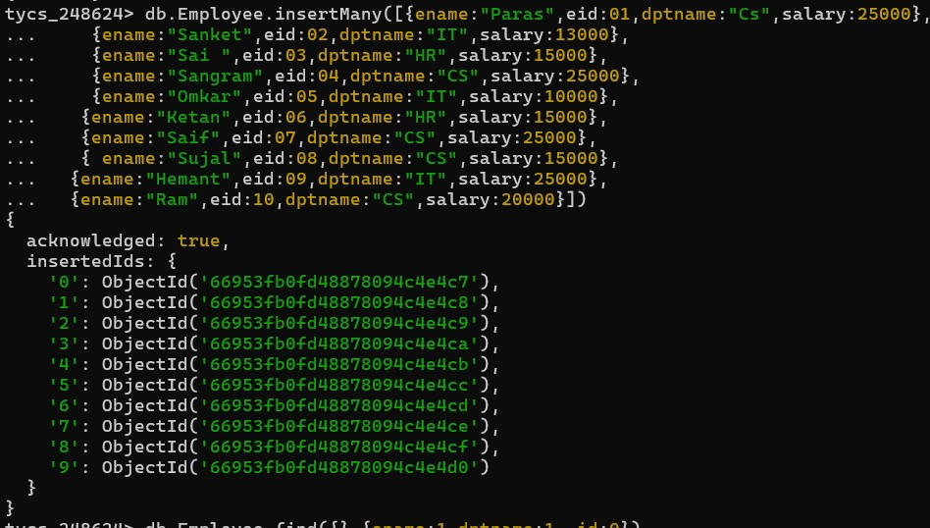

3.Write a MongoDB query to display the fields employee_id, name, department, but exclude the field _id for all the documents in the collection employee.

db.employee.find({},{ename:1,eid:1,dptname:1,_id:0})

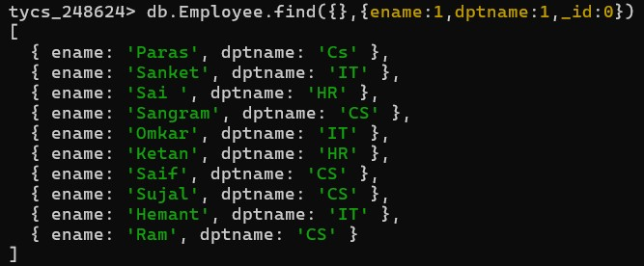

4.Write a MongoDB query to display all the employee which are in the “IT” department

.db.employee.find({department:”IT”})

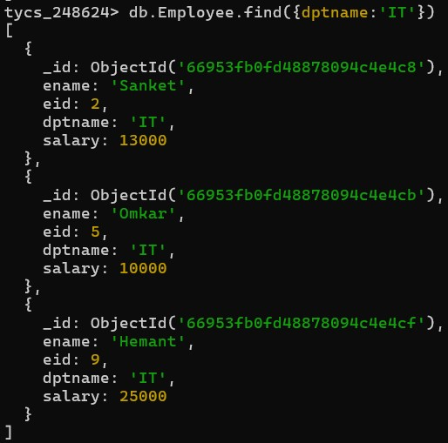

5.Write a MongoDB query to set salary of the employee to 50,000 for employees which are in “HR” department .

db.employee.updateMany({dptname:”HR”},{$set:{salary:50000}})

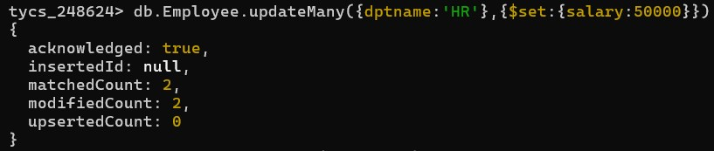

6.Write a MongoDB query to set price 10 for the products whose quantity is greater then 50. db.product.updateMany({quantity:{$gt:50}},{$set:{price:10}})

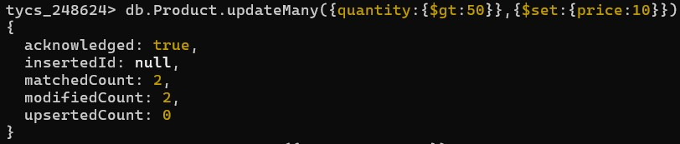

7.Write a MongoDB query to remove the record of any one product.

db.product.remove({pname:”bag”})

8.Write a MongoDB query to rename product collection as Product_details.

db.product.renameCollection(“product_details”)

